FOOTWEAR INDUSTRY
Student Name:
Institution Name:
Date:

Table of Contents
Table of Contents 2
The Footwear Industry 3
Section 1: Introduction 3
Section 2: Merging Trends 4
2.1 New digital retail strategies 4
2.2 Home-wellness footwear 5
2.3 Price and value for money 5
2.4 Change in supply chain strategies 5
2.5 Sustainability and commitments 5
Section 3: Evolution and Illustrative Examples 6
3.1 Men and Ladies’ Sandals 6
3.2 Ladies High heels 7
3.3 Sports shoes 7
3.4 Loafers 8
Section 4: Effects of the trends in the industry 8
4.1 New digital retail strategies 8
4.2 Home-wellness footwear 9
4.3 Price and value for money 9
4.4. Change in supply chain strategies 9
4.5 Sustainability and commitments 9
Products I would launch. 10
References 11

The Footwear Industry

Section 1: Introduction
The footwear industry forms an essential area of the economy of growing nations because of the following reasons. First, footwear may be acknowledged as a primary need item, watching closely, in essence, other needs like clothing. Shoes are part of clothing. Secondly, the manufactures of footwear utilize moderately labor-intensive methods and thus adds considerably to the creation of employment opportunities. Lastly, growing nations hold a comparative position in the production and exportation of footwear to industrialized nations: therefore, this industry could be the spring of much demanded international trade.
According to Adulyanukosol and Silpcharu, 2020). The global footwear industry is divided according to nature, raw materials, end-user, supply channel, and country. By nature, the industry is classified into athletic and nonathletic. Depending on the type of raw material, it is divided into leather and non-leather. It is categorized into supermarkets, customized storehouses, brand outlets, online sales channels, and others based on the delivery channel. Region-wise, it is separated across North America (U.S., Canada, and Mexico), Europe (UK, Germany, France, Italy, Spain, and Rest of Europe), Asia-Pacific (China, Japan, India, Australia & New Zealand, ASEAN and rest of Asia-Pacific), and LAMEA (Latin America, Middle East, and Africa). The influential opponents working in the Global Footwear Market are BATA BRANDS, Burberry, Alexander McQueen, VF Corporation, Hermes, Jimmy Choo, HUGO BOSS, Adidas AG, Nike Inc., Puma SE, Skechers USA Inc. and others.

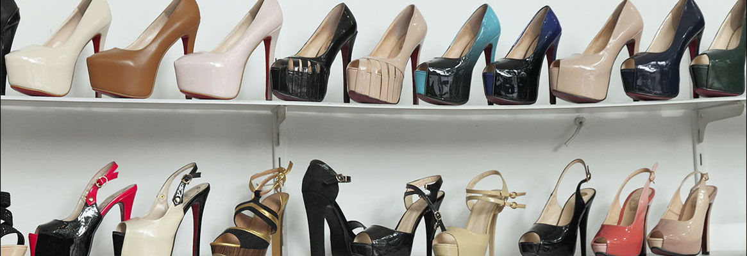
Figure 1: Footwear industry

Section 2: Merging Trends
Given the COVID-19 pandemic that has affected all industries globally, the pandemic has also resulted in the most recent trends in the footwear industry (Abdurakhmanova, 2020). The five significant trends include;

2.1 New digital retail strategies
With the pandemic, many people have by all means avoided visiting physical stores and malls to get footwear. The footwear industry is among the sectors that have established and adopted new digital retail strategies. Some of these digital strategies include door delivery and order pickup, as well as virtual shopping appointments and Livestream shopping. Excellent examples of this are Old Navy and American Eagle. They have adopted curbside item selections at a customer's pickup station of choice. They have also introduced a platform for the companies to streamline products live on the internet and interact with clients on a real-time basis.

2.2 Home-wellness footwear
COVID-19 lockdown has caused gyms and workout areas to be closed. Footwear consumers still need to remain active and exercise from homes. The footwear industry and companies have taken this positively and come up with footers that their consumers can comfortably use to exercise in the comfort of their homes (Leand, 2020).

2.3 Price and value for money
During the pandemic, people lost jobs; breadwinners lost jobs. The little cash that families had decided to save for food and other basic needs and abandon luxuries like footwear. In order to resolve the issue in customer reduction, footwear brands and retailers decided to offer heavy discounts on their products to stimulate customer demand, which has worked well for the industry.

2.4 Change in supply chain strategies
From the time the COVID-19 pandemic hit the world, footwear manufacturers and retailers have been under pressure because of the restricted internal travels, factory shutdowns and retail store closures. This has had an impact on the footwear industry. Footwear manufactures have successful adopted different supply chain strategies, including local marketing, especially for those international traders like NIKE company.

2.5 Sustainability and commitments
Sometimes, all that customers need are their companies to show them support and connect with them both personally and emotionally. This has been one of the significant trends in the footwear industry during this pandemic. Many footwear manufacturers like NIKE company have increasingly taken a stand on social issues through their social media platforms. This was evident in the Black Lives Matter campaign. Numerous footwear brands, including NIKE, posted comments to express their solidarity and show commitment to their clients.

Section 3: Evolution and Illustrative Examples
The footwear industry began as early as 10,000 BCE, and up to today, the 21st century, the footwear industry has tremendously grown.

3.1 Men and Ladies’ Sandals
One of the first footwear products were sandals. Different countries had different materials for making sandals, including sisal plant sandals, wooden sandals, and palm leaf sandals. Over year and year, sandals are increasingly becoming cuter and expensive (Ofileanu, 2017).
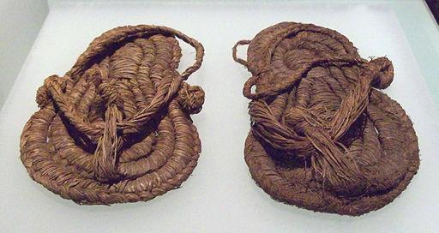
Figure 2: Traditional Sisal sandals
Figure 3: Modern-day sandals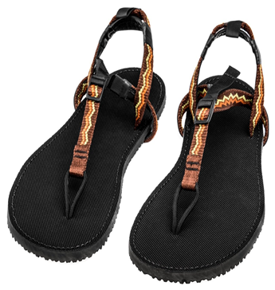

3.2 Ladies High heels
One of the most widespread evolutions in the footwear industry is the evolution of high heels. Though heels were earlier used to prevent Persian female soldiers from sticking when shooting their bows, today, high heels are the most fashionable shoes a lady would dream of owning, even kids.
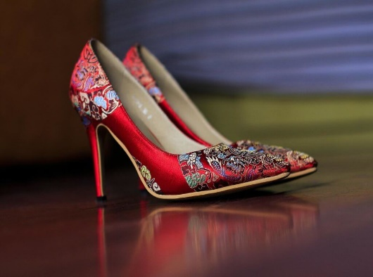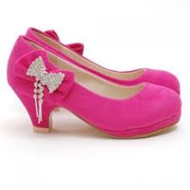
Figure 4: Ladies heels Figure 5: High heels for kids

3.3 Sports shoes
In the past few centuries, sportsmen and women had no special footwear for them to use in sports. But, thanks to the evolutions in the footwear industry, sportsmen and women have all sorts of sports footwear.
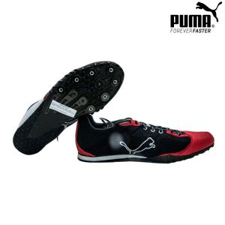
Figure 6: Puma sportswear

3.4 Loafers
Loafers are among the most footwear trending in the 21st century. Everybody, both men and women, want this loafer style.
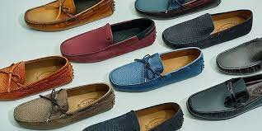
Figure 7: Loafers

Section 4: Effects of the trends in the industry
These trends will affect the future of the footwear industry in the following ways;

4.1 New digital retail strategies
Moving from traditional to digital selling is a trend that will forever positively impact the footwear industry. We live in a digital world where the internet and technology have become our lifestyle. Today, even a kindergarten kid would tell you the latest trending news on the internet. At every dawn, we meet new and more advanced technological tools. This means that technology will remain to be part of our lives. This is an advantage for the footwear industry because everything will be moved to digital platforms in the next decade.

4.2 Home-wellness footwear
CCOVID-19 pandemic has caused many people to realize the things they can do more comfortably in their homes. This includes physical exercises. Apartment owners have also understood the need to build houses with personal family gyms. This means public gyms will encounter a reduced number of customers as people would prefer working out from their homes. This means the footwear industry is here to stay.

4.3 Price and value for money
Price discounts are one of the best ways to attract customers. Giving heavy discounts to customers will help the footwear industry to also retain customers, especially budget-conscious clients. And such customers will never relocate to another seller if you keep offering price discounts.

4.4. Change in supply chain strategies
According to Munny et al. (2019), many companies always focus on international markets and retailers as the fastest platform to sell their products. But, during this pandemic, many footwear manufactures adopted the need to invest more in local markets. This change will enable such companies to well-serve the local markets, making it difficult for new entry businesses to survive. And definitely, the footwear industry will remain flourishing.

4.5 Sustainability and commitments
Showing commitments to customers is not primarily creating the best products but socially being there for the clients. Footwear companies like NIKE, which have socially supported their customers through movements like the “Black Lives Matter Campaign”, have left a permanent scar in their client’s memories. These clients will never choose another seller. Therefore, the footwear industry will remain competitive.

Products I would launch.
If I were a product marketing manager, the product that I would launch is pregnant mother’s shoes. Pregnant mothers are people who need the best care, and everything around them should be comfortable for the safety of both the mother and the infant. Many expectant mothers end up using one pair of shoes throughout their pregnancy period. They use the same pair of shoes for work, home, grocery shopping and even clinic visits. This is not because they do not have money to buy 100 pairs of shoes but because they cannot find specific types of shoes to make their pregnancy journey comfortable. Most pregnant mothers experience physical changes, especially feet swelling; they need the kind of shoes to quickly adjust to such changes. Therefore, I would launch shoes specifically for pregnant mothers, stylish and comfortable shoes for them to comfortably walk to work, shops and malls throughout their pregnancy journey and even first days after birth.
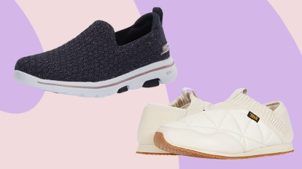
Figure 8: comfortable shoes for pregnant mothers

References
Abdurakhmanova, F. A. (2020). Trends of the global footwear market. Prospects for the development of the leather and footwear industry in the Bukhara region. Retrieved from https://media.neliti.com/media/publications/343065-trends-of-global-footwear-market-prospec-20c8b017.pdf
Adulyanukosol, A., & Silpcharu, T. (2020). Footwear Design Strategies for the Thai Footwear Industry to Be Excellent in the World Market. Journal of Open Innovation: Technology, Market, and Complexity, 6(1), 5. Retrieved from https://doi.org/10.3390/joitmc6010005
Leand, J. (2020). Theory of Evolution: Outdoor footwear for fall 2013 is adapting to new consumer and environmental demands. Retrieved from https://footwearplusmagazine.com/features/theory-of-evolution/
Munny, A. A., Ali, S. M., Kabir, G., Moktadir, M. A., Rahman, T., & Mahtab, Z. (2019). Enablers of social sustainability in the supply chain: An example of footwear industry from an emerging economy. Sustainable Production and Consumption, 20, 230-242. https://doi.org/10.1016/j.spc.2019.07.003
Ofileanu, D, 2017. Romanian Footwear Industry-Evolutions And Characteristics, Annals - Economy Series. Constantin Brancusi University, Faculty of Economics, 6, 190-194, Retrieved from. https://ideas.repec.org/a/cbu/jrnlec/y2014v6p190-194.html

